ClubUML Spring 2014 1/29/2014

**Topic: Validation Research Name: Ameya Joshi**

The objective of this week was to start with the validation schemes of the three pages; index.jsp, register.jsp and display.jsp.

I took up register.jsp and Sahil Patil is doing index.jsp. The third page is yet to be assigned.

**Progress so far:**

* I did some modifications to the on-the-fly check if an username is taken, making it more understandable to the user.

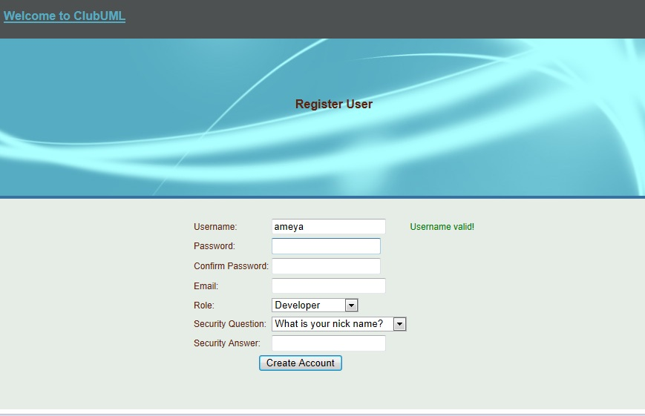

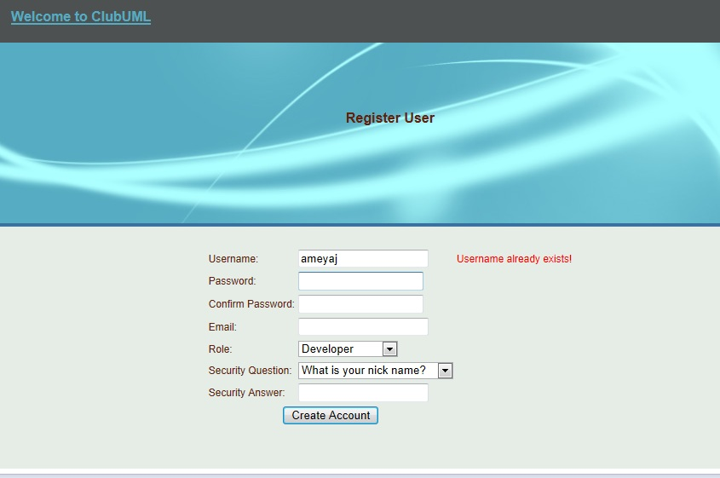

* Incorporated some constraints on the password using Regular Expressions to make it more safe and secure from SQL Injections. Using JavaScript for this makes it safer as the actual string is not passed to the servlet and this makes sure that even if there is an SQL Injection, it would never get executed.

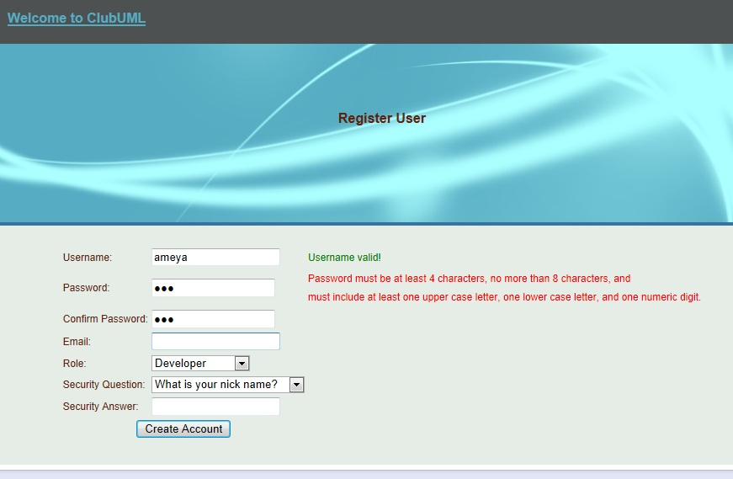

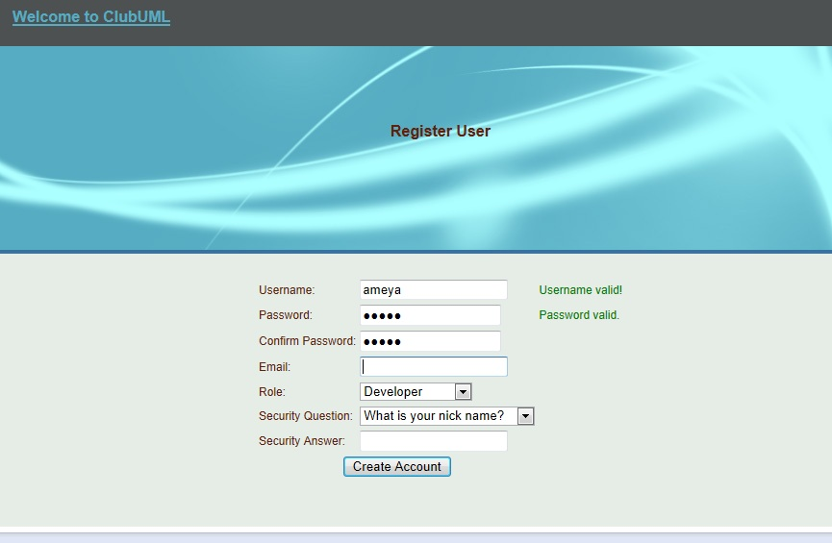

* Researching into Regular Expressions and making one for password pattern and integrating it with the current JavaScript took most of the time.

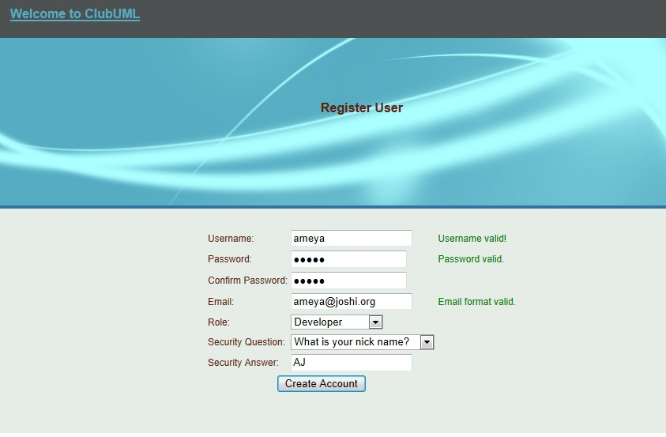

**Further work:**

Working on the email verification which might take up to a week to research the process and implement it.